**CS5551**

**ADVANCED SOFTWARE ENGINEERING**

**PROJECT PLAN (PG-10)**

**TITLE: AUTOPROFILE**

**Submitted By**:

Bhuvana Atluri (Class ID-3)

Venkata Sai Spandana Surapaneni (Class ID -47)

Vepuri Bhargavi (Class ID-52)

Venkata Nagaraj Voonna (Class ID-53)

**Project Plan**

**I. Introduction:**

In the present engaged world, individuals are occupied with numerous works and will be unable to receive all the mobile calls. Despite the fact that he can intimate the calling individual by manually sending a message. However to do this he need to pay consideration on the mobile, which at last drags out spotlight on work. So to beat this circumstance we propose an auto profile application. Auto profile procedure implies it consequently moves the profile in time intervals, if we have not attended the call it automatically sends the message to concerned call person.

**II. Project Goal and Objectives (revised)**

**Overall goal:** When we are in some critical gathering or not in a position to go to the call. Naturally profile is enacted which we plan it and sends message to concerned call individual. As this is a portable application one can without much of a stretch compose his profile at whatever point he need to perform a specific errand as every his necessity.

* Permits complete spotlight on tasks without agonizing over approaching calls.
* Client can choose the timings and profile mode depending up on necessities.

**Specific objectives (problem statement):** In Existing system we can only set the profile (profile activation) of the user manually that is whenever we are not in a position to attend the call we cannot send any message automatically but we can send it manually afterwards not at the particular time and we have no such applications to alert the important persons automatically whenever we can are not in a position to attend the call. So we propose this Auto profile as solution.

**Significance:** In the proposed framework an application is developed on android platform, which is utilized to make custom profile and compose tasks which we plan according to our prerequisite. This helps such that we need not consider about the calls when we are in some essential gathering or not in a situation to attend to the call. Consequently profile is initiated which we plan and sends message to concerned call individual. As this is a versatile application one can undoubtedly sort out this activity at whatever point we need to perform a specific assignment according to our necessity.

Advantages:

* Allows complete focus on tasks without worrying about incoming calls.
* User can select the timings and profile mode depending up on requirements.

**III. Project Background and Related Work:**

Now-a-days one of the rapidly growing industries are mobile industries. There are numerous competitors who are doing innovative work on new stages & client experience. One such innovation is Android from Google which is upheld for Google mobiles. Utilizing this android stage we can create tweaked applications. Until now we have a facility to send message manually whenever we reject a call. But there is no such application to send customized messages automatically without the involvement of user whenever the call is missed.

**IV. Proposed System**

**1) Requirement Specification**

**Functional:**

The application sends a message to the caller whenever the called person does not respond. In order to do this first the user has to create a profile. In that profile he specifies the time period and the message to be delivered. Once the profile is saved then automatically a message will be delivered to the caller. The user can set multiple profiles depending on the requirement. For example he can set profiles for 2pm as “I am in a meeting” and at 3pm “I am in driving”. The application must be able to switch between these multiple profiles. The user can activate, deactivate, update, or delete his profile at any time. He can also verify the message which is delivered to which person.

**Non Functional:**

Nonfunctional requirements mainly defines the quality and the implementation of the system. The performance of the application depends on the real time response for all the activities performed by the user. Validation of the inputs provided by the user i.e. two profiles cannot be created at the same time as the user cannot be have two profiles at the same time.

**System features:**

Coding Language : Java (JDK 1.6) or Android SDK

Database : Microsoft SQL Server 2008

IDE : Eclipse or Indigo IDE

**2) Framework Specification**

**Assumptions and Principles**

* The mobile should support android operating system.
* The mobile should have sufficient SMS credits.
* The one who is using the mobile must have a minimum knowledge how to create profile in the application and add multiple profiles in the application.

**Activity Diagram:**



**System Architecture Diagram:**

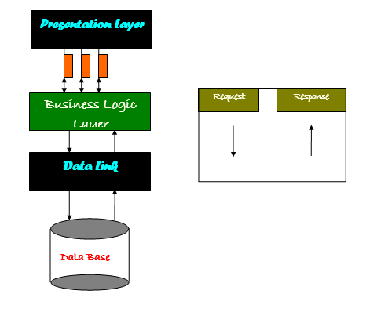

**3) System Specification:**

**Existing Services:**

1. Name: Messaging Service

Description: Messaging Service is used to send messages between the mobile devices using the mobile network

URL: <http://developer.android.com/reference/android/os/Message.html>

2. Name: SMS Scheduler

Description: SMS scheduler allows to create new text messages and schedule a time to send the message to the recipient.

URL: <https://play.google.com/store/apps/details?id=com.gizmoquip.smsscheduler>

**New Services to be built:**

**1. Create Profile:** A profile is created with the profile details like profile name, time for profile activation, specified message for the profile.

Input: Creation of Profile based on the desired requirements

Output: Profile is created successfully.

**Class Diagram:**



**Sequence Diagram:**



**2. Auto Profile Activation**: Profile activation initializes the service for the profile whenever recipient can’t attend the call from the caller.

Input: Whenever a call is missed Autoprofile is activated.

Output: Specified message is sent to the caller.

Class Diagram:



**Sequence Diagram:**



**3. Auto Profile Switching**: Auto Profile switching switches between the different profiles depending on the time intervals scheduled by the user.

Input: Multiple profiles are created depending on different times.

Output: Message is send to the recipient depending on the time by switching between the profiles.

**Class Diagram for Overview of Project:**



**Design of Mobile Client:**

Technologies used to develop this application are:

**For Frontend design:**

Eclipse IDE, Java JDK 1.6

**Backend:**

Microsoft SQL Server 2008

**V. Plan by Services (using ScrumDo):**

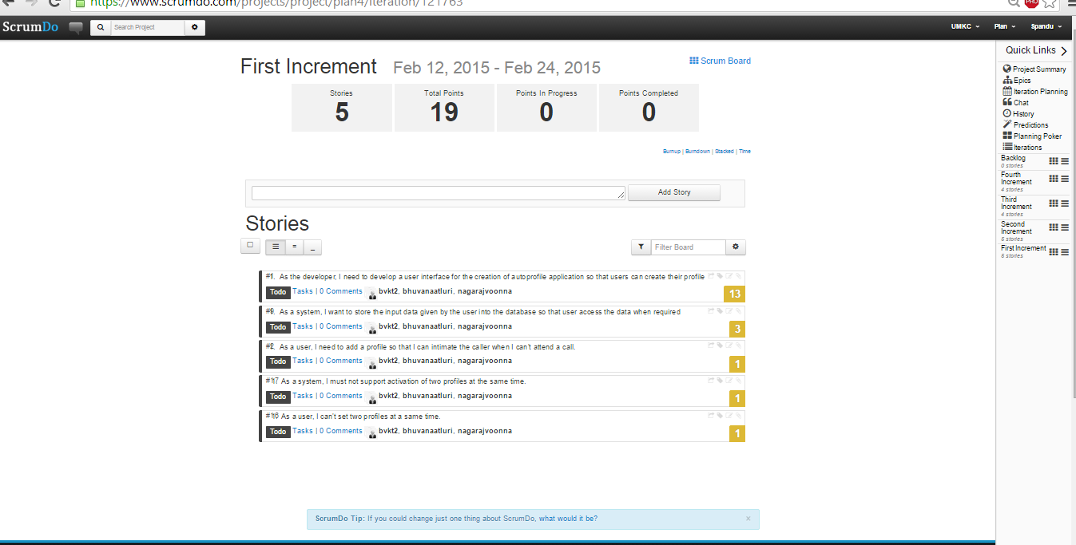

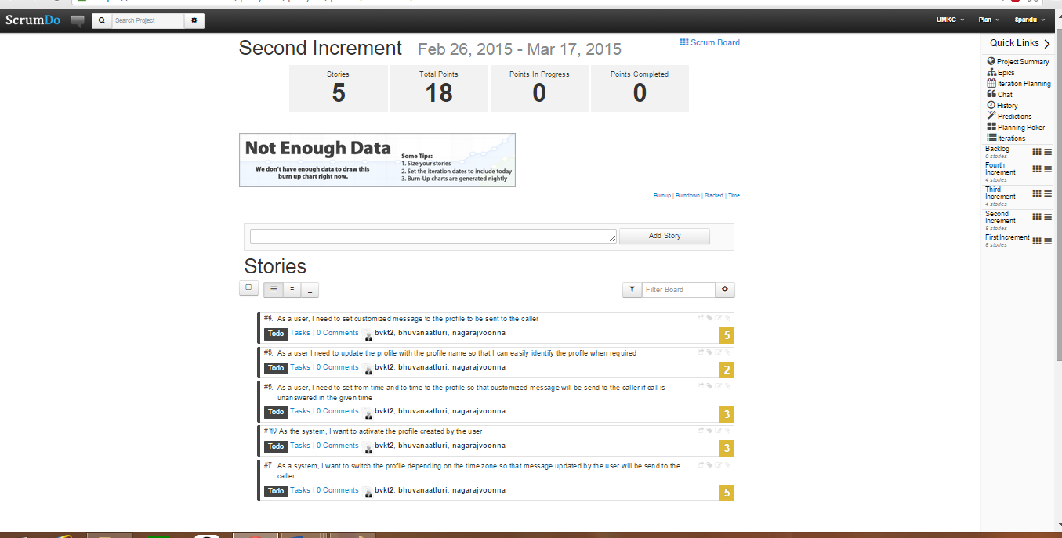

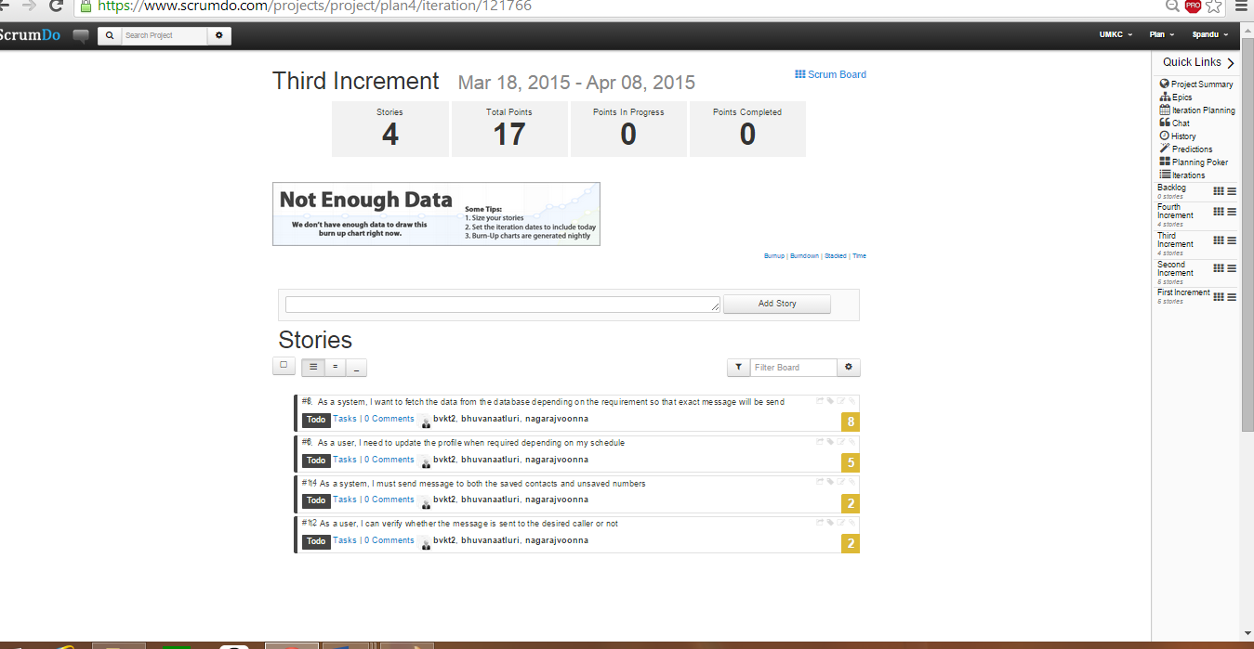

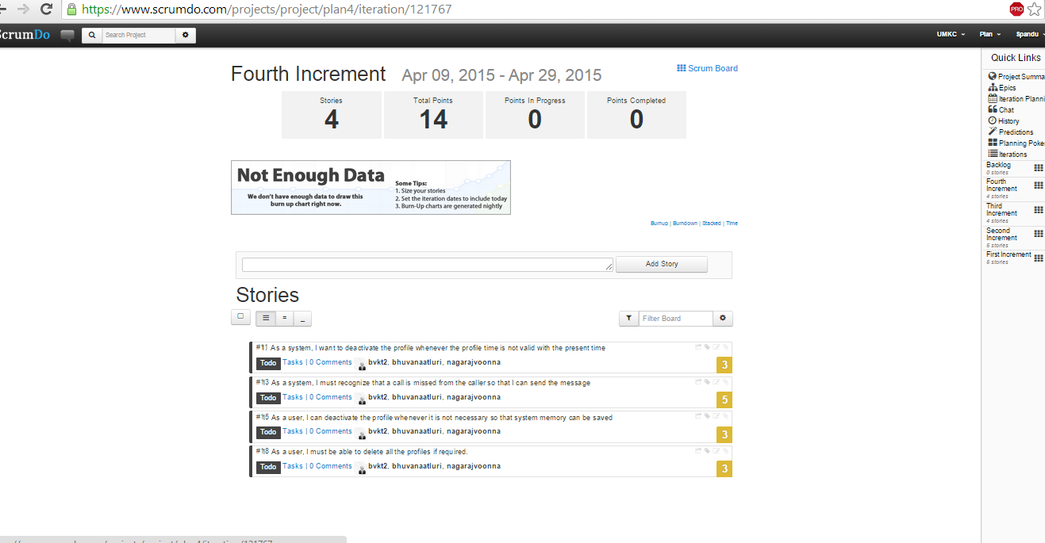

**Bibliography:**

<http://developer.android.com/index.html>

<http://www.w3schools.com/>

<https://www.microsoft.com/learning/en-us/sql-training.aspx>

<https://eclipse.org/home/>